**Q1: Model the following fragment of a business process for assessing loan applications. A loan application may be coupled with a home insurance which is offered at discounted prices. The applicants may express their interest in a home insurance plan at the time of submitting their loan application to the loan provider. Based on this information, if the loan application is approved, the loan provider may either only send an acceptance pack to the applicant, or also send a home insurance quote. The process then continues with the verification of the repayment agreement.**

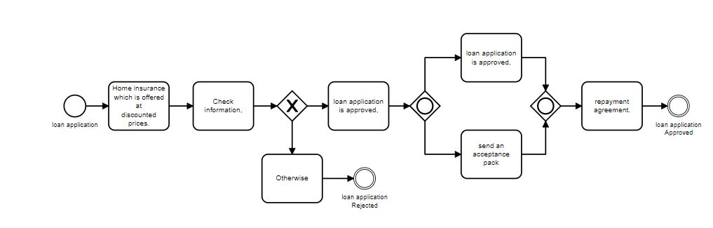

**Question 2: Model the following fragment of a business process for assessing loan**

**applications. Once a loan application is received by the loan provider, and before proceeding**

**with its assessment, the application itself needs to be checked for completeness. If the**

**application is incomplete, it is returned to the applicant, so that they can fill out the missing**

**information and send it back to the loan provider. This process is repeated until the application**

**is found complete.**

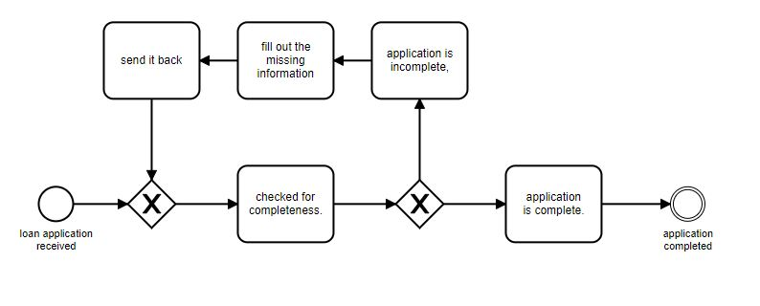

Q**3: Model the following fragment of a business process for assessing loan**

**applications. A loan application is approved if it passes two checks: (i) the applicant’s loan risk**

**assessment, done automatically by a system, and (ii) the appraisal of the property for which the**

**loan has been asked, carried out by a property appraiser. The risk assessment requires a credit**

**history check on the applicant, which is performed by a financial officer. Once both the loan**

**risk assessment and the property appraisal have been performed, a loan officer can assess the**

**applicant’s eligibility. If the applicant is not eligible, the application is rejected, otherwise the**

**acceptance pack is prepared and sent to the applicant.**

